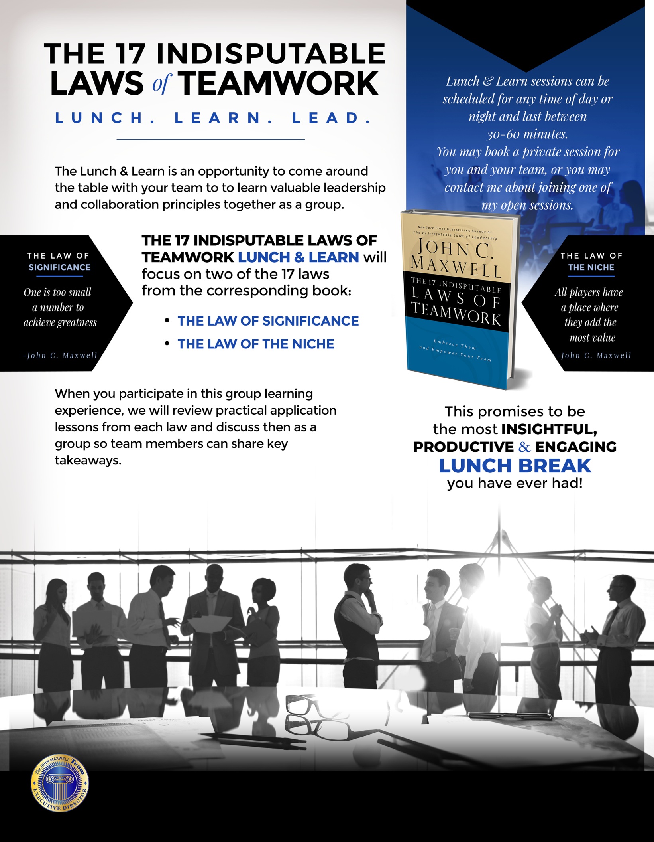

ABOUT ROB DINERMAN
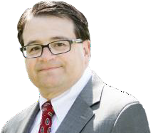
Rob Dinerman is Vice President of Marketing and Membership for the Wharton Club of New York and an Executive Director and Board Member for The John Maxwell Team (JMT), a 36,000 member global think-tank for Business and Leadership Transformation. In 1993 Rob met John for the first time and has continued to teach and learn from John as his friend and mentee. Rob is also President of Dinerman Leadership Solutions which offers performance coaching and professional development services.

Rob began his career at Salomon Brothers where he worked on the Government and newly formed Mortgage Backed Securities trading desks. After developing trading systems there, he moved into technology, managing teams at tech companies like Oracle, Sun, and Gartner when he managed the global teams for AmerisourceBergen and Medco.

Rob earned his BS in Economics from Wharton, majoring in Finance, Accounting as well as a Psychology degree from Penn. He is very active locally, serving as Vice President of the New Providence Board of Education and The Union County School Board Association.

Contact me to schedule this workshop for your company.
(908) 403-7430 | rob@robertdinerman.com

